EXPT. NO: 13 | POINTERS
DATE:12.2.2021 | POINTERS
Aim:
To write a C program for the following to
- Swap the value of two numbers using call by value and call by reference
- Sort a list of names using pointers
1.Swap the value of two numbers using call by value
Algorithm
- Start the program
- PRINT Enter Value of x:
- GET a
- PRINT Enter Value of y:
- GET b
- PRINT a = a b = b
- CALL swapx(&a, &b)
- STOP

- FUNCTION swapx START
- COMPUTE t = *x
- COMPUTE *x = *y
- COMPUTE *y = t
- PRINT x = *x y = *y
- RETURN

Program
#include <stdio.h>
int main() {
int a, b;
printf("Enter Value of x: ");
scanf("%d", &a);
printf("\nEnter Value of y: ");
scanf("%d", &b);
printf("a=%d b=%d\n", a, b);
swapx(a, b);
return 0;
}
int swapx(int x, int y) {
int t;
t = x;
x = y;
y = t;
printf("x=%d y=%d\n", x, y);
}
Output
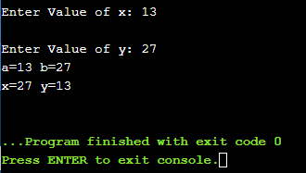
2.Swap the value of two numbers using call by reference
Algorithm
- Start the program
- PRINT Enter Value of x:
- GET a
- PRINT Enter Value of y:
- GET b
- PRINT a = a b = b
- CALL swapx(&a, &b)
- STOP

- FUNCTION swapx START
- COMPUTE t = *x
- COMPUTE *x = *y
- COMPUTE *y = t
- PRINT x = *x y = *y
- RETURN
Program
#include <stdio.h>
int main() {
int a, b;
printf("Enter Value of x: ");
scanf("%d", &a);
printf("\nEnter Value of y: ");
scanf("%d", &b);
printf("a=%d b=%d\n", a, b);
swapx(&a, &b);
return 0;
}
int swapx(int* x, int* y) {
int t;
t = *x;
*x = *y;
*y = t;
printf("x=%d y=%d\n", *x, *y);
}
Output
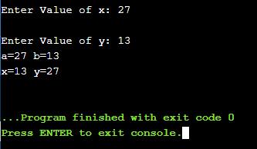
3.Sort a list of names using pointers
Algorithm
- Start
- PRINT Enter no. of String :
- GET n
- FOR 0 to n
- PRINT Enter the Strings
- GET x[i]
- CALL reorder
- PRINT reorder list is:
- FOR 0 to n
- PRINT x[i]

- START Function reorder
- FOR i = 0 to n-1
- FOR j = i+1 o n
- IF x[i] strcmp(x[i],x[j])>0
- T = x[j]
- x[j] = x[i]
- x[i] = t
- RETURN
Program
#include<stdio.h>
#include<string.h>
int main() {
char *x[20];
int i, n=0;
int reorder(int n,char *x[]);
printf("Enter no. of String : ");
scanf("%d",&n);
printf("\n");
for(i=0;i<n;i++) {
printf("Enter the Strings %d : ",i+1);
x[i]=(char *)malloc(20*sizeof(char));
scanf("%s",x[i]);
}
reorder(n,x);
printf("\nreorder list is : \n");
for(i=0;i<n;i++) {
printf("%d %s\n",i+1,x[i]);
}
}
int reorder(int n,char *x[]) {
int i,j;
char t[20];
for(i=0;i<n-1;i++)
for(j=i+1;j<n;j++)
if(strcmp(x[i],x[j])>0) {
strcpy(t,x[j]);
strcpy(x[j],x[i]);
strcpy(x[i],t);
}
return;
}
Output
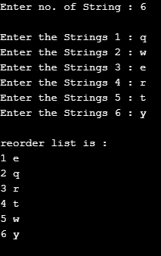

Result
Thus the C program was written and executed successfully for the following
- Swap the value of two numbers using call by value and call by reference
- Sort a list of names using pointers

